Unit4TestCLocal

1 CE8A - Who is an elected county official who arrest lawbreakers?

2 CE8A - Who creates the political subdivisions called local governments in Virginia?

3 CE8A - Powers of the local government are delegated from the _____ or the state.

4
City | City Council
Town | Town Council
Counties | ?
CE8A - What item BEST completes the diagram?

5
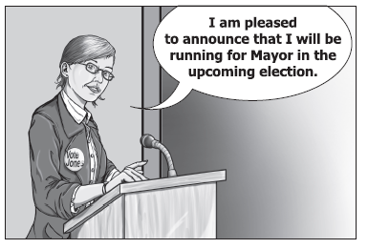
CE8A - One way for Mrs. Jones to gain this office is to be elected by registered voters of the _____.

6 CE8A - What part of local government oversees public schools in the county?

7 CE8A - What is an ordinance?

8 CE8A - Which government unit adopts ordinances for Isle of Wright County?

9 CE8A - In Virginia cities, who creates ordinances?

10
CE8A - Why would the local government pass an ordinance illustrated by the picture above?
11 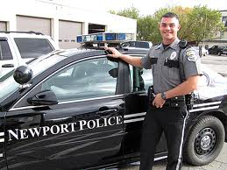
CE8A - Local governments are given the power to _____ as illustrated by the picture above.

12 CE8A - When local officials enforce laws that help protect air quality and natural resources, such as oyster beds in the Chesapeake Bay, they are exercising their power to protect the _____.

13 CE8A – The state might delegate the responsibility to develop _____ curriculum to local government?

14 CE8B - The authority of local government in Virginia comes from the _____.

15 CE8B - Where are the powers of city governments listed?

16 CE8B - A charter is a _____ plan of government.

17 CE8B - Virginia’s local governments receive all their powers from the Virginia Constitution and acts of the _____.

18 CE8C - Why do counties, cities, and towns adopt and enforce ordinances?

19 CE8C - Individuals have the greatest influence on decisions made by _____ government officials.

20 CE8C - How do citizens learn the importance of an individual’s participation in the law-making process?

21 CE8C – Write an example of an effective way to learn the importance of an individual’s participation in the local lawmaking process?

22 CE9C - The West Nile virus was first identified in Africa. Today, mosquitoes spread the disease in many parts of the world. The Virginia Department of Health sprays locally to kill mosquitoes. What international area of concern is the local government responding to?

23 CE9C - The Department of Homeland Security has raised the terrorist threat level to yellow. The Virginia Department of Emergency Management increases patrols around bridges and tunnels. What international area of concern is the local government responding to?

24 CE9C - The City of Newport News is recruiting international businesses to relocate their business to the city and create new jobs for local residents. The city is offering tax breaks to these international businesses as a way to motivate them. What international area of concern is the local government responding to?

25 CE9C - The Chesapeake Bay Foundation lobbies Newport News government officials about improving the quality of water in local waterways. What area of concern are local government officials discussing?

26 CE9C – List three issues of concern to local governments. Give an example for two.

27 CE9C - Local governments preparing a response for an international health crisis would most likely develop a _____ plan for the city.
Unit4TestCLocal
Answer Section

MULTIPLE CHOICE

1 ANS: C PTS: 1

2 ANS: G PTS: 1

3 ANS: C PTS: 1

4 ANS: F PTS: 1

5 ANS: D PTS: 1

6 ANS: H PTS: 1

7 ANS: C PTS: 1

8 ANS: J PTS: 1

9 ANS: B PTS: 1

10 ANS: F PTS: 1

11 ANS: D PTS: 1

12 ANS: H PTS: 1

13 ANS: C PTS: 1

14 ANS: H PTS: 1

15 ANS: B PTS: 1

16 ANS: F PTS: 1

17 ANS: D PTS: 1

18 ANS: G PTS: 1

19 ANS: B PTS: 1

20 ANS: F PTS: 1

21 ANS: A PTS: 1

22 ANS: H PTS: 1

23 ANS: D PTS: 1

24 ANS: F PTS: 1

25 ANS: B PTS: 1

26 ANS: H PTS: 1

27 ANS: B PTS: 1

